
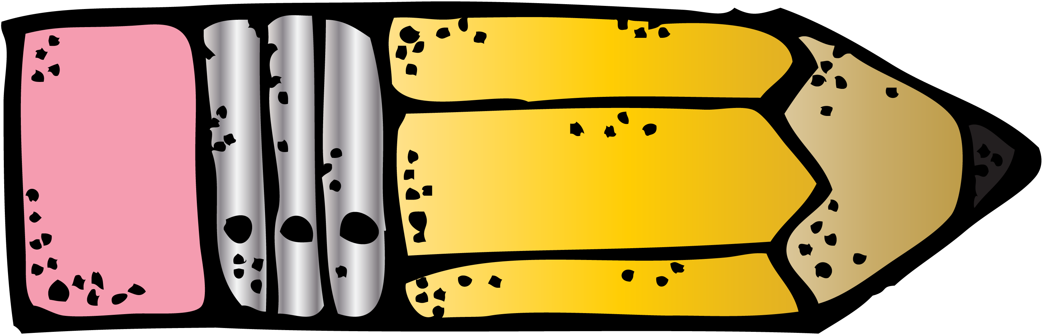
August 22, 2022

We have had eight busy days getting acquainted with each other, learning about our room and some areas of the school, and getting to know the rules and routines. It has been a productive and happy start to the school year! I appreciate your patience as I tried to get children home safely from school. Things have really gone smoothly. It is quite a challenge to keep up with each child’s mode of transportation; so please remember, if you change your child’s “going home” arrangements, send a written note in your child’s KID folder. Many notes are never seen if they are placed in back packs or lunch boxes. Remember, to ensure the safety of your child, I must send your child home by the usual means unless I receive written notification from you (or in an emergency, a call to the office).

Ask your child about some of the activities we did the last eight days…

- After reading The Kissing Hand, we followed clues that Chester the Raccoon left for us around our school! We learned about our campus and ate the yummy chocolate kisses he left in our classroom.
- For art we made Buck Lake Bobcats for the letter B.
- After reading Brown Bear Brown Bear, we created bear-shaped envelopes to hold the characters from the story. Ask your child to tell you the story in the correct sequence.
- After reading Who Took the Cookies from the Cookie Jar, we practiced reading our names and chanting the rhyme.
- After reading No David! we learned all about the BLE “rules and procedures”.
- We created many graphs! (eye color, favorite color, how many boys and girls are in our class)
- We painted Chicka Chicka Boom Boom trees.
- We completed pages A-G in our alphabet books.
- We learned all about numbers 1 and 2.


This week we will focus on two letters a day. We will complete letters H-Q and have fun reading books and completing art projects related to the letters.



We will continue Chapter 1: Represent, Count, and Write Numbers 0 to 5 from our math program this week. Our focus will be on the numbers 3 & 4. The number formation poems are on my website under math. I will be sending home practice pages for you to work on with your child at home. Please do not work ahead in the chapter. I do not need the math pages returned to school.

We will start the BLE Terrific Kid program this week. I will select one child weekly who has exhibited excellent behavior. Please check the Terrific Kids icon on my website to learn about the program and to see when your child is selected. This is a special honor and I hope that each child will work toward earning it!

I would like to send out a giant thank you to Amy Powell (Koen’s mom) for offering to be our room parent! She will communicate with you as needed regarding school events.

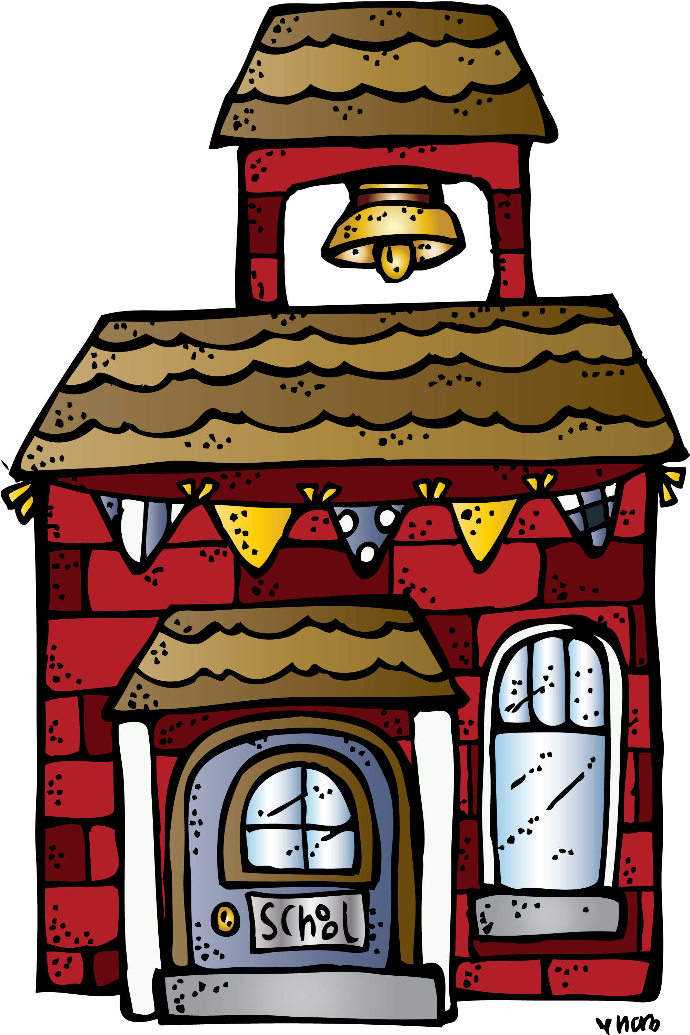
Please read the information recently sent home and remember to mark your calendar with upcoming events. It is also important that forms be filled out and returned if you have not already done so. Please contact me by note or call the school office if you have any questions or concerns. I will return your call as soon as possible. I will utilize my website to relay information to you in a timely manner. Please check every Monday for important news. If you do not have access to the internet, please let me know so that I can find other means to update you. I will send newsletters via e-mail and updates when I feel it is necessary. Not running copies saves paper and valuable time. If you have not already done so, please be sure to register for Buck Lake’s listserv to receive school information. Click here to join the Buck Lake Listserv!

Upcoming Dates:
Tuesday, August 30th: Skate World Share Night
Wednesday, August 31st: Spirit Sales End
Thursday, September 1st: Open House for K 6:00-7:30pm
Monday, September 5th: Labor Day Holiday (No School)

Again, your children are precious and delightful. I really appreciate the way you taught them to listen and follow directions. Many of them are coming to school with skills that are making our class a wonderful place to learn.

Thanks again,
Sonja Darden

dardens@leonschools.net

